**JENKINS AND CONTINUOUS INTEGRATION**

A report by,

Aayush Pathak

Danish K. Chaus

Interns at TCS, Powai

Submitted on: 4/7/2016

Submitted to: Mrs. Vrushali

**TABLE OF CONTENTS:**

1. Introduction

2. Installing Jenkins

3. Jenkins Modules

4.

**JENKINS AND CONTINUOUS INTEGRATION**

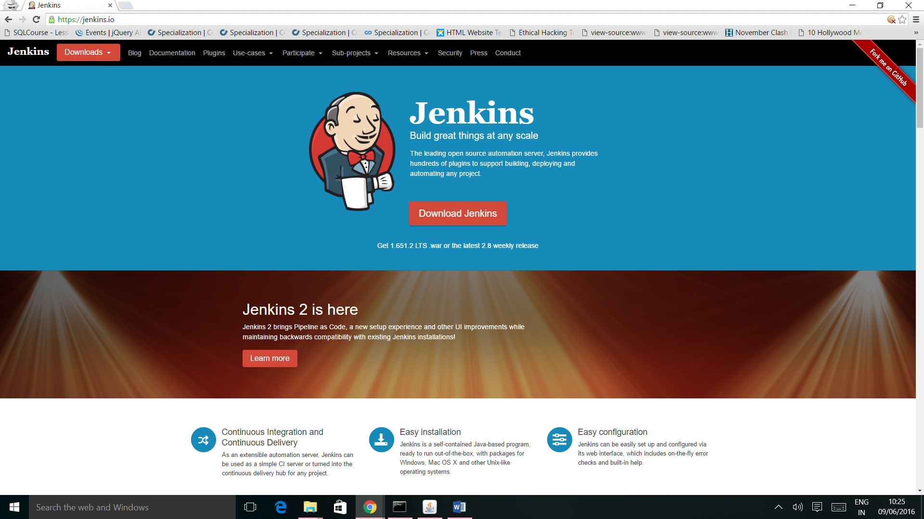

**1. INTRODUCTION:**

**1.1 JENKINS:**

Jenkins is an open-source continuous integration software tool written in the Java programming language for testing and reporting on isolated changes in a larger code base in real time. The software enables developers to find and solve defects in a code base rapidly and to automate testing of their builds.

**1.2 CONTINUOUS INTEGRATION:**

Continuous Integration is a development practice that requires developers to integrate code into a shared repository at regular intervals. Continuous integration requires the developers to have frequent builds. The common practice is that whenever a code commit occurs, a build should be triggered.

**2. INSTALLING JENKINS:**

**2.1 REQUIREMENTS:**

1. JDK must be installed on the system.
2. Memory: 2GB RAM

**2.2 WINDOWS INSTALLATION:**

**Download link:** https://jenkins.io/

On the Jenkins Homepage (<https://jenkins.io/>), click **“Download Jenkins”** and select the long-term support release.

**Starting Jenkins:**

In command prompt, browse to the directory where the jenkins.war file is present. Run the following command:

“**Java –jar jenkins.war**”

Once processing is complete, the following line will be output:

“**Jenkins is fully up and running**”

Now Jenkins can be accessed from the link: “**http://localhost:8080/**”

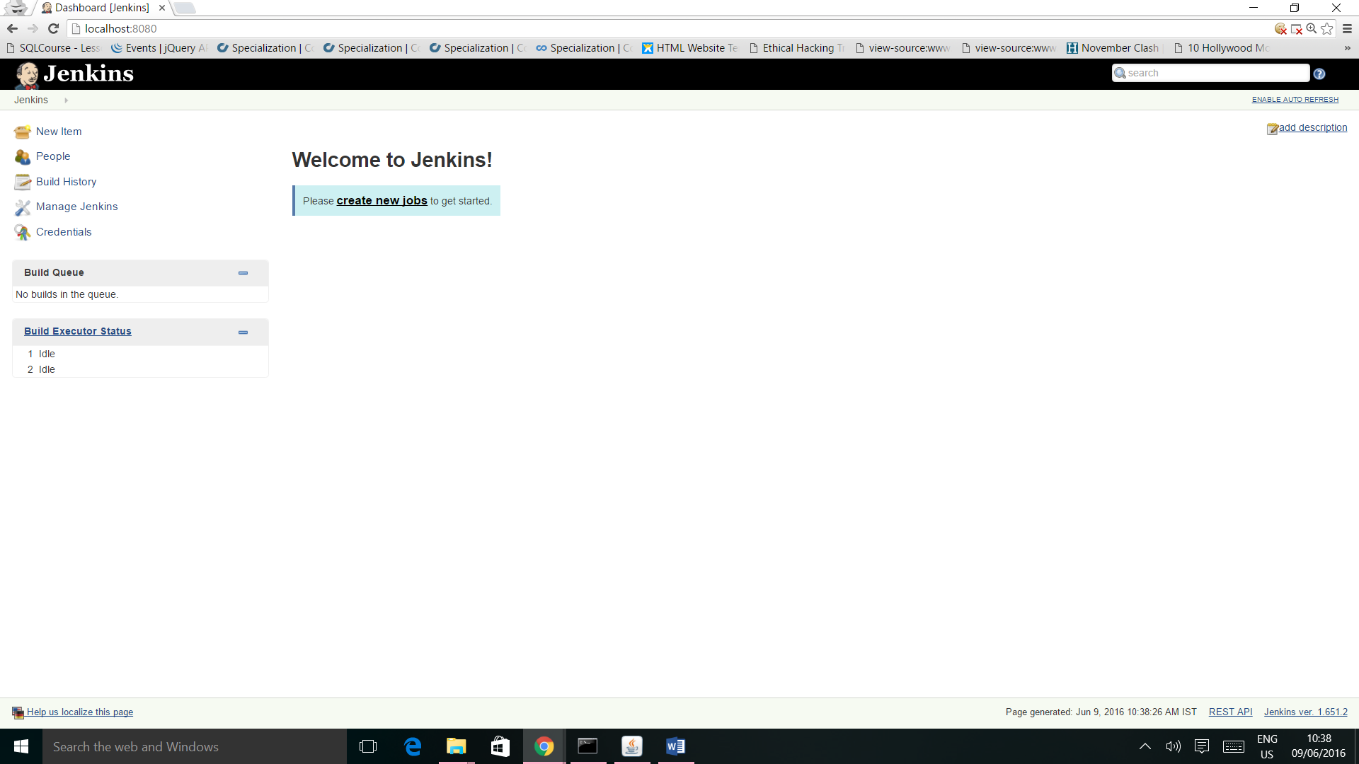

**2.3 LINUX INSTALLATION:**

Run the following commands in terminal to install Jenkins:

1. wget -q -O - https://jenkins-ci.org/debian/jenkins-ci.org.key | sudo apt-key add -

2. sudo sh -c 'echo deb http://pkg.jenkins-ci.org/debian-stable binary/ > /etc/apt/sources.list.d/jenkins.list'

3. sudo apt-get update

4. sudo apt-get install jenkins

**3. JENKINS MODULES:**

**3.1 NEW ITEM:**

This module is used to create a new project/item in jenkins. To create a new item:

1. Enter Item Name

2. Select type of Project

3. Click OK.

The configuration window for the Item opens up. Enter the configuration details and click Save.

**3.2 PEOPLE:**

It includes all known “users”, including login identities which the current security realm can enumerate, as well as people mentioned in commit messages in recorded changelog.

**3.3 BUILD HISTORY:**

It gives the details of all the builds of the items created by the user.

**3.4 MANAGE JENKINS:**

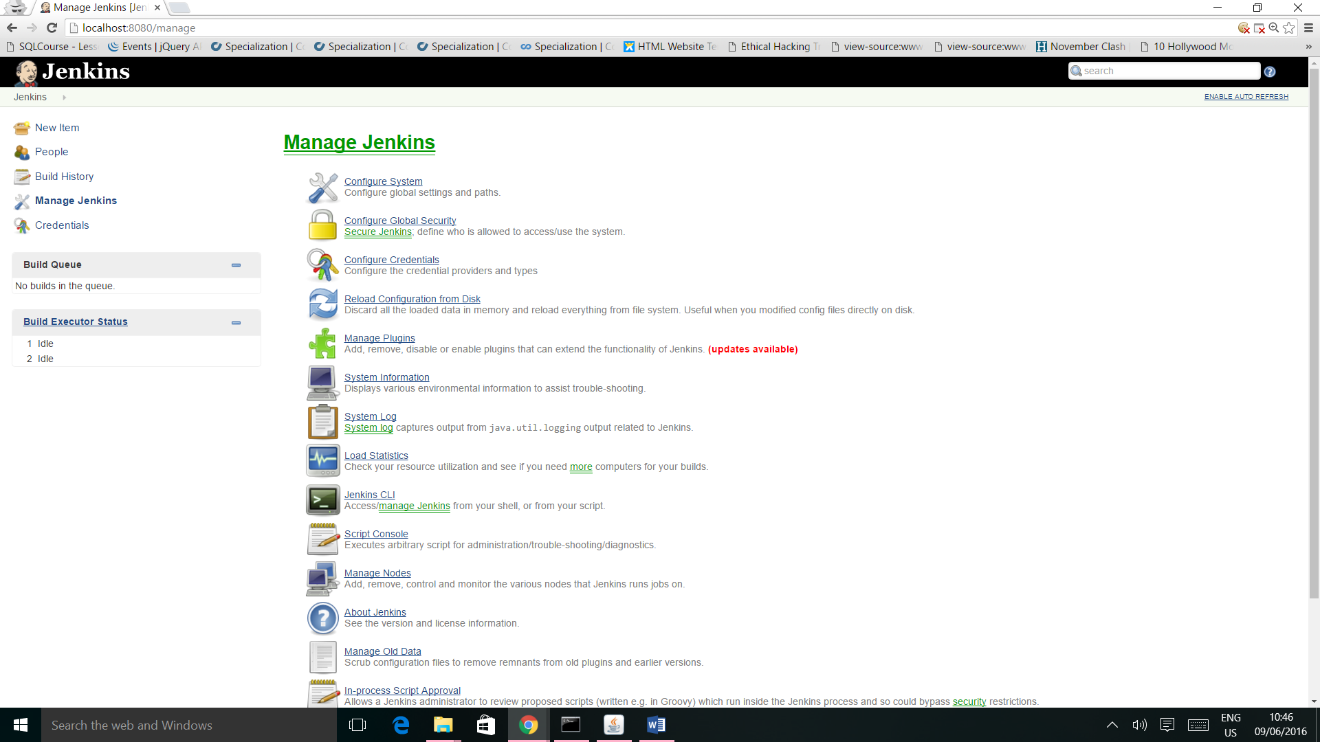

To manage Jenkins, click on the ‘Manage Jenkins’ option from the left hand menu side. So one can get the various configuration options for Jenkins by clicking the ‘Manage Jenkins’ option from the left hand menu side.

Some of the sub modules available under MANAGE JENKINS are:

**3.4.1 CONFIGURE SYSTEM:**

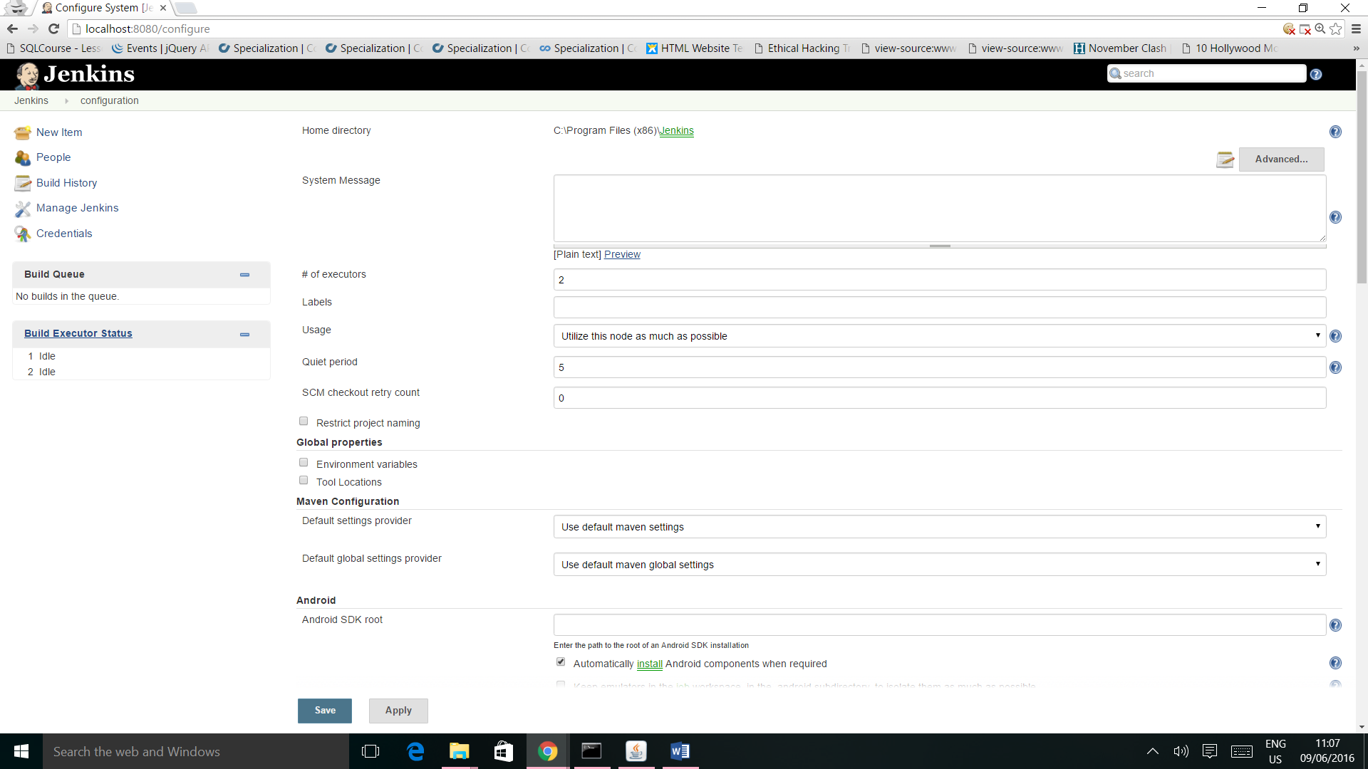

This is where one can manage paths to the various tools to use in builds, such as the JDKs, the versions of Ant and Maven, as well as security options, email servers, and other system-wide configuration details. When plugins are installed. Jenkins will add the required configuration fields dynamically after the plugins are installed.

**3.4.2 MANAGE PLUGINS:**

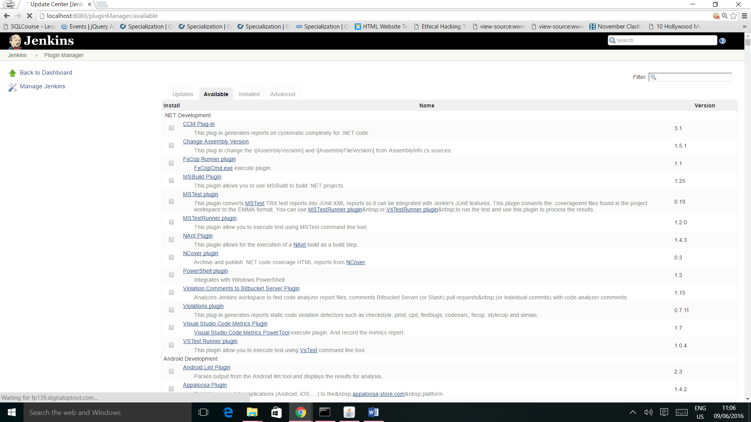

Here one can install a wide variety of third-party plugins right from different Source code management tools such as Git, Android Emulator Plugin, etc. Plugins can be installed, updated and removed through the Manage Plugins screen.

* Android Emulator Plugin: Starts an Android emulator with given properties before a build, then shuts it down after.
* Git Plugin: This plugin integrates [Git](http://git.or.cz/) with Jenkins.

**3.4.3 CREATING NEW USER:**

To create a new user in Jenkins, follow the following steps:

*Click Manage Jenkins -> Configure Global Security -> Enable Security -> Jenkins Own*

*User Database -> Save.*

This will turn ON the ***create users*** tab in ***Manage Jenkins.***

After this new user can be created using following steps:

*Click Manage Jenkins -> Manage User -> Create User -> Add Details -> Signup.*

